Church on the Hill
A Congregation of the
Reformed Church in America
167-07 35th Avenue, Flushing, NY 11358
May 3, 2020
11:00 a.m.

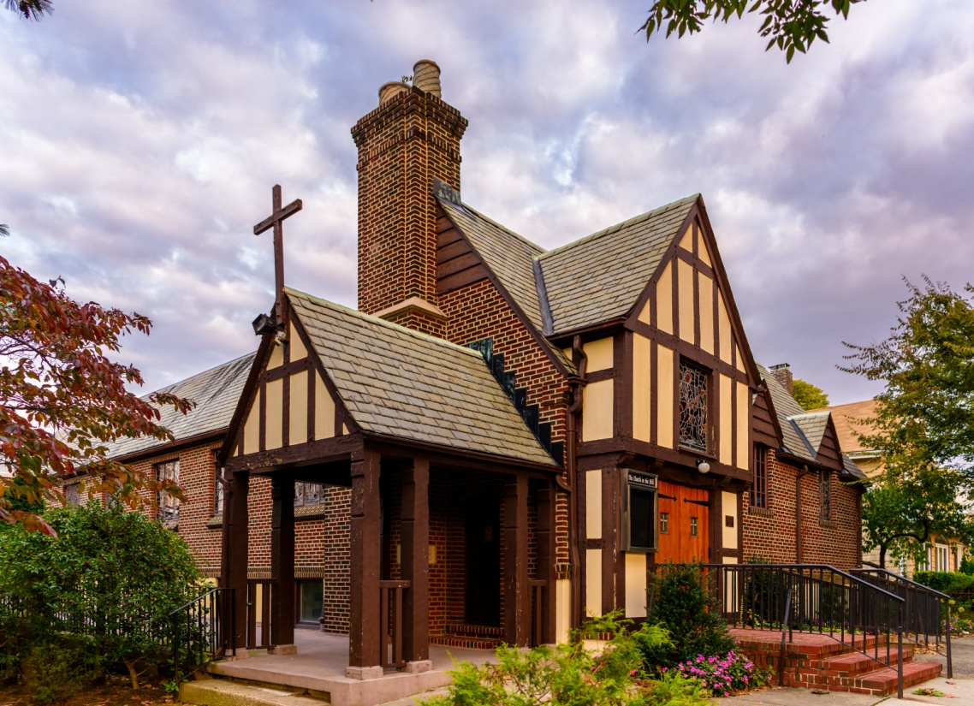
©Emerson Chen Photography

Rev. Blaine D. Crawford – Pastor
Mr. Sean Cotty – Music Director
Rev. Robert A. Perless – Pastor Emeritus

ORDER FOR WORSHIP
BOLD – Congregation responds

PRELUDE Improvisation on O Waly Waly Sean Cotty

VOTUM

SENTENCES

PRAYER OF INVOCATION
Almighty God,
to whom all hearts are open,
all desires known,
and from whom no secrets are hid:
Cleanse the thoughts of our hearts
by the inspiration of your Holy Spirit,
that we may perfectly love you
and worthily magnify your holy name
through Christ, our Lord. Amen.

CALL TO WORSHIP

HYMN No. 593 The Gift of Love
Though I may speak with bravest fire,
and have the gift to all inspire,
and have not love: my words are vain;
as sounding brass, and hopeless gain.

Come, Spirit, come, our hearts control,
our spirits long to be made whole.
Let inward love guide every deed;
by this we worship, and are freed

PRAYER OF CONFESSION
Almighty and eternal God,
you have loved us with unfailing, self-giving mercy,
but we have not loved you.
You constantly call us, but we do not listen.
You ask us to love, but we walk away from neighbors in need, wrapped in our own concerns.
God of grace, as you come to us in mercy,
we repent in spirit and in truth,
admit our sin, and gratefully receive your forgiveness
through Jesus Christ, our Redeemer.
(Silent prayers of confession and unburdening)
Amen.

ASSURANCE OF PARDON/WISDOM FOR LIFE
(Based on writings from 1 Peter)

SOLO Pie Jesu (from the Requiem) Gabriel Faure
Soloist: Maureen Saepia-Chen
(Sung in Latin)
Merciful Lord Jesus,
grant them rest,
eternal rest.

PRAYER OF ILLUMINATION
Lord, we do not always find it easy
to recognize your coming to us.
Come, reveal yourself to us.
Set our heavy hearts on fire with love for you,
and send us on our way rejoicing.
For your name’s sake, Amen.

SCRIPTURE READINGS
Acts 2:42-47
1 Peter 2:1-10
This is the Word of the Lord.
Thanks be to God.

SERMON A House for God Rev. Blaine
Crawford

CONFESSION OF FAITH
The mystery of the faith:
Christ has died. Christ is risen! Christ will come again!

HYMN No. 356 All Creatures of Our God and King
All creatures of our God and King,
lift up your voice and with us sing
Alleluia, Alleluia!
Thou burning sun with golden beam,
thou silver moon with softer gleam,
O praise him, O praise him,
Alleluia, Alleluia, Alleluia!

Let all things their Creator bless,
and worship him in humbleness,
O praise him, Alleluia!
Praise, praise the Father, praise the Son,
and praise the Spirit, Three in One,
O praise him, O praise him,
Alleluia, Alleluia, Alleluia!

PRAYERS OF THE PEOPLE
Lord’s Prayer
Our Father, who art in heaven,
hallowed by Thy name.
Thy Kingdom come, thy will be done,
on earth as it is in Heaven.
Give us this day our daily bread;
and forgive us our trespasses
as we forgive those who trespass against us.
Lead us not into temptation,
but deliver us from evil.
For thine is the Kingdom and the power
And the glory, forever. Amen.

ANNOUNCEMENTS

BENEDICTION

POSTLUDE Improvisation on Old Hundredth Sean Cotty

If you would like to add a loved one to the prayer list,
please contact the church office.

Miram Allen
John Babinsky
Diane Blagburn
Christina Boll
Elizabeth Bossis
Lillian Calfa
David Cerqueira
Gracinda Cerqueira
Jose Cerqueira
Marilyn Cooney
Edward Cotty
Helen Cunningham
Rosina Cuticone
Lenny DeSimone
Herb Durdik
The Frocione Family
Brooke Graffeo
Rosemarie Graffeo
Jayne Halley
Bill Haasters’ Family
Hotchkiss Family
The Lynch Family
Ed Mangiarotti
Jorge & Tiffany Martinez
Gerry & Jean Mendler
Ruben & Eva Munoz
Patricia Olney
The Smith Family
Joe Thorsen
Christie Tweed
Alison Venable
Joan Werbel
Sandy Weston

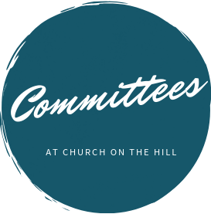

Buildings & Grounds
Chair: Joe Macaluso
Consistory Rep: Maureen
Saepia-Chen

Christian Education & Youth
Chair: Jeanne Sarran

Community, Mission & Outreach
Co-Chairs: Yoon Ryo &
Patrick Symes

Community Nursery
School Board
President: Ginny Chan
Consistory Rep: Dorien Day

Congregational Care
Co-Chairs: Angela Brunjes & Pamela Lopez
*Chairperson is also Consistory Representative unless otherwise stated.
_____________________________________________________________________________

Children are always welcome in worship at Church on the Hill. At the back of the sanctuary, the Family Room is open for young children and their parents. Restrooms are located downstairs in Gessner Hall, where you will find a changing table in one of the bathrooms.
_____________________________________________________________________________

_____________________________________________________________________________

The sanctuary is looped for the hard of hearing. In order to connect to the system, please sit in the north set of pews (on your right when you enter the sanctuary) and set your hearing device to the “T” setting.

Finance
Chair: Doris Krsnak
Consistory Rep: Margret
Dougherty

Personnel
Chair: Dana Chan

Worship & Music
Chair: Rev. Crawford
Consistory Rep: Irma Schubert

Rev. Blaine Crawford, President
Nancy Gessner, Clerk
Elders | Deacons
Angela Brunjes | Dana Chan
Dorien Day | Margaret Dougherty
Pam Lopez | Yoon Ryo
Jeanne Sarran (VP) | Maureen Saepia-Chen
Irma Schubert | Patrick Symes

Rev. Blaine Crawford, Minister: pastor@churchonthehill.org
Sean Cotty, Music Director: sean.cotty@churchonthehill.org
Molly Mahowald, Office Administrator: office@churchonthehill.org

*Revised Office Hours: M–F, 10:30 a.m.-3:30 p.m.
Phone: (718) 358-3671
www.churchonthehill.org

