Church on the Hill
A Congregation of the
Reformed Church in America
167-07 35th Avenue, Flushing, NY 11358
May 17, 2020
11:00 a.m.

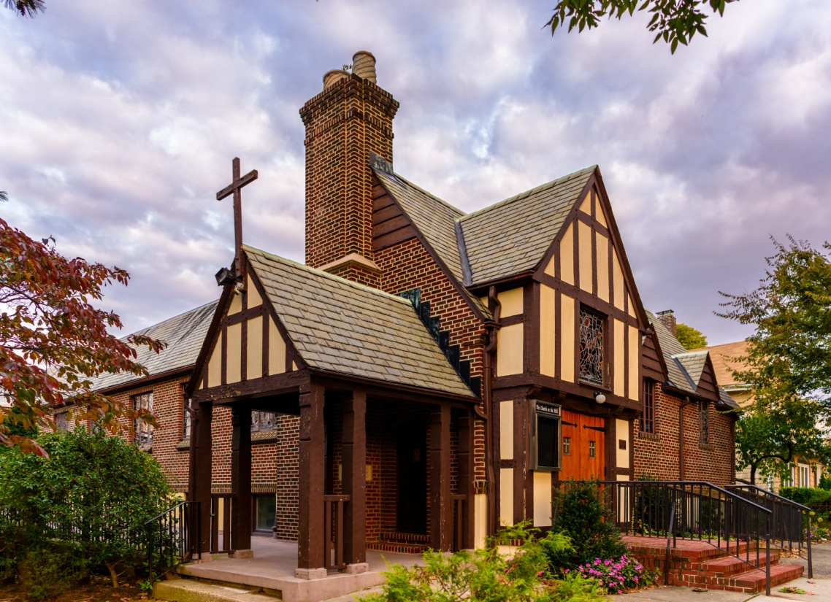
©Emerson Chen Photography

Rev. Blaine D. Crawford – Pastor
Mr. Sean Cotty – Music Director
Rev. Robert A. Perless – Pastor Emeritus

ORDER FOR WORSHIP
BOLD – Congregation responds

PRELUDE Improvisation on O Filii et Filiae Sean Cotty

VOTUM

SENTENCES

PRAYER OF INVOCATION
O God,
by your power may we, with all the saints,
comprehend the breadth and length and height and depth of the love of Christ that surpasses knowledge,
so that we may be filled with your fullness. Amen.

CALL TO WORSHIP

HYMN No. 263 Alleluia, Sing to Jesus
Alleluia, sing to Jesus! his the scepter, his the throne:
Alleluia! his the triumph, his the victory alone.
Hark! the songs of peaceful Zion Thunder like a mighty flood. Jesus, out of every nation, has redeemed us by his blood.

Alleluia! heavenly High Priest, here on earth our help, our stay: Alleluia! hear the sinful cry to you from day to day.
Intercessor, friend of sinners, earth's Redeemer, hear our plea, where the songs of all the sinless sweep across the crystal sea.

PRAYER OF CONFESSION
O God of shalom,
we have built up walls to protect ourselves from our enemies,
but those walls also shut us off from receiving your love.
Break down those walls.
O God of shalom,
we have also not loved our neighbors as ourselves,
especially when they thwart, frustrate, or annoy us.
Help us to see that the way to your heart
is through the healing of our own hearts.
(Silent prayers of confession and unburdening)
Amen.

ASSURANCE OF PARDON/WISDOM FOR LIFE
(Based on writings from 1 Peter)

SOLO Marvelous Mystery (He Died for Me) Joy Sandford
Soloist: Dorien Day
Marvelous Mystery!
Christ was perfect in His Deity,
Yet, He came to earth that I might see,
He died for me.
Worthy I’ll never be, still He took my sins to Calvary,
They were nailed with Him upon the tree to set me free.
He was the Son of God!
He didn’t have to stay.
He could have turned His back on me and walked away;
But lovingly, willingly, He took the road to Calvary,
Saving me for all eternity.
He died for me.

PRAYER OF ILLUMINATION
Almighty God, you have spoken to us through your Son.
Let your written Word now be spoken and heard by each of us.
Give us ears to hear and hearts to understand,
that we may not refuse your calling or ignore your voice.
May we all be taught by you through your powerful Word.
Bring our every thought captive to obeying Christ,
to the glory of your holy name. Amen.

SCRIPTURE READINGS
Psalm 66:8-20
1 Peter 3:8-22
This is the Word of the Lord.
Thanks be to God.

SERMON A Clear Conscience Rev. Blaine
Crawford

CONFESSION OF FAITH
The mystery of the faith:
Christ has died. Christ is risen! Christ will come again!

HYMN No. 349 I Love You Lord, My Strength, My Rock
I love you, Lord, my strength, my rock, my fortress, and my aid. My refuge and salvation's hope, to you I long have prayed. Though cords and snares encompassed me, confronting me with death, in my distress I called to you, my life and source of breath.

For who is God except the Lord, my rock, my strength, my stay. Salvation's shield you give to me, you widen victory's way. Blest be your name, O Living God, the victory you have won. Your name I will proclaim to all, O saving Sovereign One.

PRAYERS OF THE PEOPLE
Lord’s Prayer
Our Father, who art in heaven,
hallowed by Thy name.
Thy Kingdom come, thy will be done,
on earth as it is in Heaven.
Give us this day our daily bread;
and forgive us our trespasses
as we forgive those who trespass against us.
Lead us not into temptation,
but deliver us from evil.
For thine is the Kingdom and the power
And the glory, forever. Amen.

ANNOUNCEMENTS

BENEDICTION

POSTLUDE Improvisation on Forest Green Sean Cotty

If you would like to add a loved one to the prayer list,
please contact the church office.

Miram Allen
John Babinsky
Diane Blagburn
Christina & Sadie Boll
Elizabeth Bossis
Lillian Calfa
David Cerqueira
Gracinda Cerqueira
Jose Cerqueira
Marilyn Cooney
Edward Cotty
Helen Cunningham
Rosina Cuticone
Lenny DeSimone
Herb Durdik
Lowell and Julie Fewster
The Frocione Family
Betty Gessner
Brooke Graffeo
Rosemarie Graffeo
Jayne Halley
Hotchkiss Family
Lynch Family
Jorge & Tiffany Martinez
Gerry & Jean Mendler
Ruben & Eva Munoz
Patricia Olney
The Smith Family
Joe Thorsen
Christie Tweed
Alison Venable
Joan Werbel
Sandy Weston

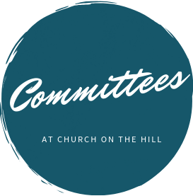

Buildings & Grounds
Chair: Joe Macaluso
Consistory Rep: Maureen
Saepia-Chen

Christian Education & Youth
Chair: Jeanne Sarran

Community, Mission & Outreach
Co-Chairs: Yoon Ryo &
Patrick Symes

Community Nursery
School Board
President: Ginny Chan
Consistory Rep: Dorien Day

Congregational Care
Co-Chairs: Angela Brunjes & Pamela Lopez
*Chairperson is also Consistory Representative unless otherwise stated.
_____________________________________________________________________________

Children are always welcome in worship at Church on the Hill. At the back of the sanctuary, the Family Room is open for young children and their parents. Restrooms are located downstairs in Gessner Hall, where you will find a changing table in one of the bathrooms.
_____________________________________________________________________________

_____________________________________________________________________________

The sanctuary is looped for the hard of hearing. In order to connect to the system, please sit in the north set of pews (on your right when you enter the sanctuary) and set your hearing device to the “T” setting.

Finance
Chair: Doris Krsnak
Consistory Rep: Margret
Dougherty

Personnel
Chair: Dana Chan

Worship & Music
Chair: Rev. Crawford
Consistory Rep: Irma Schubert

Rev. Blaine Crawford, President
Nancy Gessner, Clerk
Elders | Deacons
Angela Brunjes | Dana Chan
Dorien Day | Margaret Dougherty
Pam Lopez | Yoon Ryo
Jeanne Sarran (VP) | Maureen Saepia-Chen
Irma Schubert | Patrick Symes

Rev. Blaine Crawford, Minister: pastor@churchonthehill.org
Sean Cotty, Music Director: sean.cotty@churchonthehill.org
Molly Mahowald, Office Administrator: office@churchonthehill.org

*Revised Office Hours: M–F, 10:30 a.m.-3:30 p.m.
Phone: (718) 358-3671
www.churchonthehill.org

