Church on the Hill
A Congregation of the
Reformed Church in America
167-07 35th Avenue, Flushing, NY 11358
May 10, 2020
11:00 a.m.

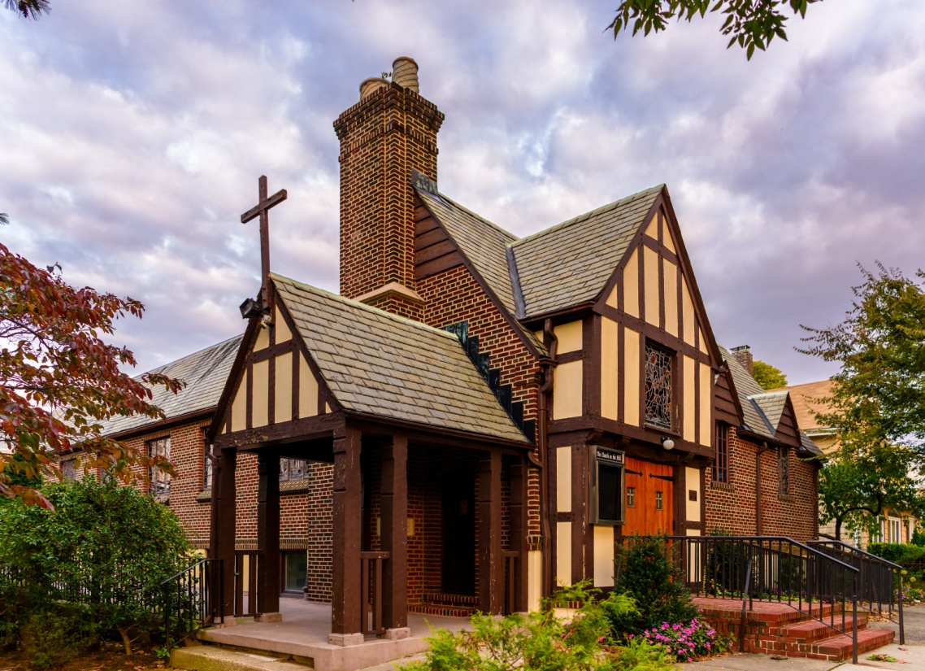
©Emerson Chen Photography

Rev. Blaine D. Crawford – Pastor
Mr. Sean Cotty – Music Director
Rev. Robert A. Perless – Pastor Emeritus

ORDER FOR WORSHIP
BOLD – Congregation responds

PRELUDE Largo from Flute Sonata in E minor G. F. Handel
Simon Walsh - Flute

VOTUM

SENTENCES

PRAYER OF INVOCATION
Mighty God,
in whom we know the power of redemption,
you stand among us in the shadows of our time.
As we move through every sorrow and trial of this life,
uphold us with knowledge of the final morning
when, in the glorious presence of your risen Son,
we will share in his resurrection,
redeemed and restored to the fullness of life
and forever freed to be your people. Amen.

CALL TO WORSHIP

HYMN No. 43 A Mighty Fortress Is Our God
A mighty fortress is our God, a bulwark never failing;
our helper He, amid the flood of mortal ills prevailing.
For still our ancient foe doth seek to work us woe;
His craft and pow'r are great, and armed with cruel hate,
on earth is not his equal.

That word above all earthly powers, no thanks to them, abideth;
the Spirit and the gifts are ours thro' him who with us sideth.
Let goods and kindred go, this mortal life also;
the body they may kill; God's truth abideth still;
His kingdom is forever.

PRAYER OF CONFESSION
Lord, we are like sheep, and we get lost.
We forget the needs of our neighbors
and do not love you above all else.
We need a Savior, so we long for Jesus.
Come, fill our lives, Jesus.
(Silent prayers of confession and unburdening)
Amen.

ASSURANCE OF PARDON/WISDOM FOR LIFE
(Based on writings from 1 Peter)

SOLO Allegro from Flute Sonata in E minor G. F. Handel
Simon Walsh - Flute

PRAYER OF ILLUMINATION
Lord God,
help us to know your ways;
teach us your paths.
Lead us in your truth, and teach us,
for you are the God of our salvation;
for you we wait all day long.
Through Christ, our Lord. Amen.

SCRIPTURE READINGS
Psalm 23
1 Peter 2:19-25
This is the Word of the Lord.
Thanks be to God.

SERMON When We Suffer Rev. Blaine
Crawford

CONFESSION OF FAITH
The mystery of the faith:
Christ has died. Christ is risen! Christ will come again!

HYMN No. 502 Amazing Grace
Amazing grace! how sweet the sound
that saved a wretch like me!
I once was lost, but now am found,
was blind but now I see.

Through many dangers, toils and snares
I have already come;
'tis grace that brought me safe thus far,
and grace will lead me home

PRAYERS OF THE PEOPLE
Lord’s Prayer
Our Father, who art in heaven,
hallowed by Thy name.
Thy Kingdom come, thy will be done,
on earth as it is in Heaven.
Give us this day our daily bread;
and forgive us our trespasses
as we forgive those who trespass against us.
Lead us not into temptation,
but deliver us from evil.
For thine is the Kingdom and the power
And the glory, forever. Amen.

ANNOUNCEMENTS

BENEDICTION

POSTLUDE Improvisation on Amazing Grace Sean Cotty

If you would like to add a loved one to the prayer list,
please contact the church office.

Miram Allen
John Babinsky
Diane Blagburn
Christina & Sadie Boll
Elizabeth Bossis
Lillian Calfa
David Cerqueira
Gracinda Cerqueira
Jose Cerqueira
Marilyn Cooney
Edward Cotty
Helen Cunningham
Rosina Cuticone
Lenny DeSimone
Herb Durdik
The Frocione Family
Brooke Graffeo
Rosemarie Graffeo
Jayne Halley
Bill Haasters’ Family
Hotchkiss Family
Lynch Family
Mangiarotti Family
Jorge & Tiffany Martinez
Gerry & Jean Mendler
Ruben & Eva Munoz
Patricia Olney
The Smith Family
Joe Thorsen
Christie Tweed
Alison Venable
Joan Werbel
Sandy Weston

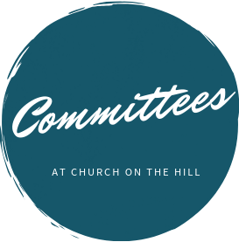

Buildings & Grounds
Chair: Joe Macaluso
Consistory Rep: Maureen
Saepia-Chen

Christian Education & Youth
Chair: Jeanne Sarran

Community, Mission & Outreach
Co-Chairs: Yoon Ryo &
Patrick Symes

Community Nursery
School Board
President: Ginny Chan
Consistory Rep: Dorien Day

Congregational Care
Co-Chairs: Angela Brunjes & Pamela Lopez
*Chairperson is also Consistory Representative unless otherwise stated.
_____________________________________________________________________________

Children are always welcome in worship at Church on the Hill. At the back of the sanctuary, the Family Room is open for young children and their parents. Restrooms are located downstairs in Gessner Hall, where you will find a changing table in one of the bathrooms.
_____________________________________________________________________________

_____________________________________________________________________________

The sanctuary is looped for the hard of hearing. In order to connect to the system, please sit in the north set of pews (on your right when you enter the sanctuary) and set your hearing device to the “T” setting.

Finance
Chair: Doris Krsnak
Consistory Rep: Margret
Dougherty

Personnel
Chair: Dana Chan

Worship & Music
Chair: Rev. Crawford
Consistory Rep: Irma Schubert

Rev. Blaine Crawford, President
Nancy Gessner, Clerk
Elders | Deacons
Angela Brunjes | Dana Chan
Dorien Day | Margaret Dougherty
Pam Lopez | Yoon Ryo
Jeanne Sarran (VP) | Maureen Saepia-Chen
Irma Schubert | Patrick Symes

Rev. Blaine Crawford, Minister: pastor@churchonthehill.org
Sean Cotty, Music Director: sean.cotty@churchonthehill.org
Molly Mahowald, Office Administrator: office@churchonthehill.org

*Revised Office Hours: M–F, 10:30 a.m.-3:30 p.m.
Phone: (718) 358-3671
www.churchonthehill.org

