Church on the Hill
A Congregation of the
Reformed Church in America
167-07 35th Avenue, Flushing, NY 11358
April 5, 2020
11:00 a.m.

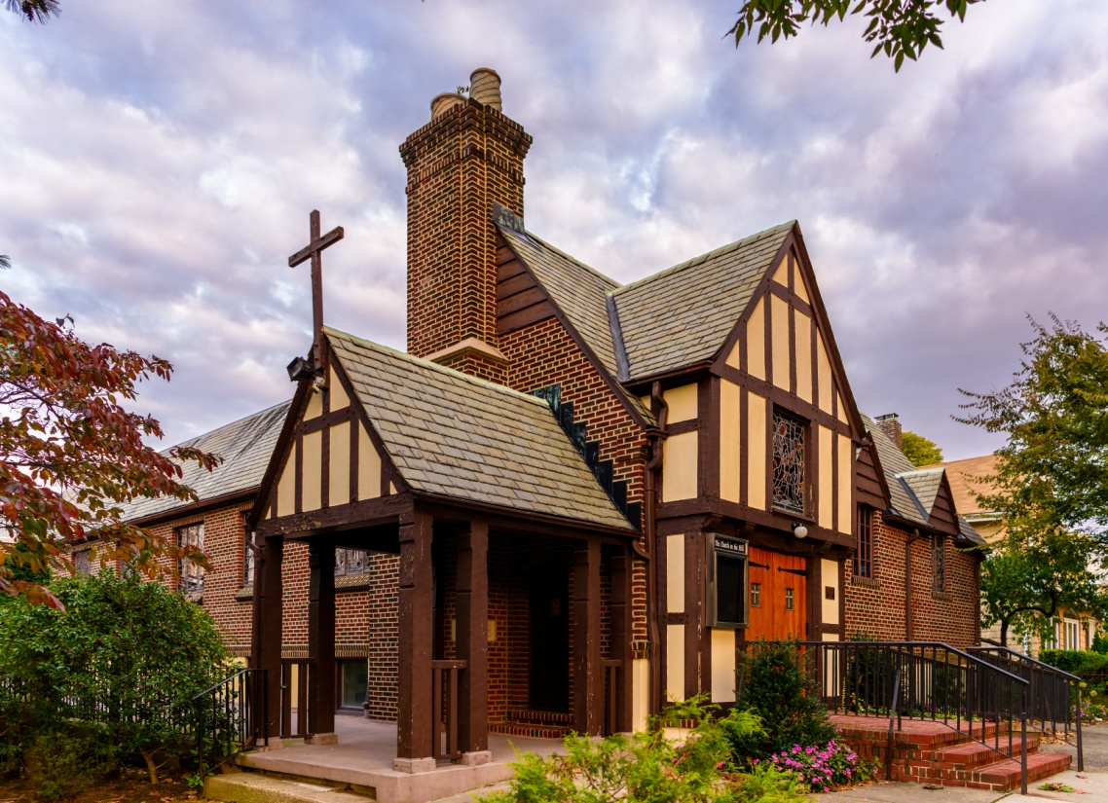
©Emerson Chen Photography

Rev. Blaine D. Crawford – Pastor
Mr. Sean Cotty – Music Director
Rev. Robert A. Perless – Pastor Emeritus

ORDER FOR WORSHIP
BOLD – Congregation responds

PRELUDE Improvisation on The Palms Sean Cotty

PRAYER OF INVOCATION

CALL TO WORSHIP
(Based on Psalm 118:19-29)
O give thanks to the LORD, for God is good.
God’s steadfast love endures forever.
The stone that the builders have rejected has become the chief cornerstone.
This is the Lord’s doing; it is marvelous in our eyes.
This is the day that the LORD has made; let us rejoice and be glad in it.
You are God and have given us light. We offer our thanks and praise to you this day.
O give thanks to the LORD, for God is good.
God’s steadfast loves endures forever.

HYMN No. 1 Hosanna, Loud Hosanna
Hosanna, loud hosanna, the little children sang;
through pillared court and temple the lovely anthem rang
to Jesus, who had blessed them close folded to his breast,
the children sang their praises, the simplest and the best.

"Hosanna in the highest!" That ancient song we sing,
for Christ is our Redeemer, the Lord of heaven, our King;
O may we ever praise him with heart and life and voice,
and in his blissful presence eternally rejoice!

PRAYER OF CONFESSION
O King of Glory,
we confess that our praise of your majesty has often been faint, our performance as citizens of your kingdom treasonous.
For we have surrendered to the enemy
by our secret and our known sins.
For our treason you died, Lord Jesus.
For our restoration, you rose again.
Draw us closer to you in this holy week,
that our eyes may catch the vision of your tears,
and our hearts, the wonder of your grace.
(Silent Prayers of Confession and Unburdening)
Amen.

ASSURANCE OF PARDON/WISDOM FOR LIFE
Hosanna to the Son of David!
Blessed is he who comes in the name of the Lord!
For Christ came into the world not to condemn the world,
but that the world through him should be saved.
Therefore, let the same mind be in you that was in Christ Jesus.
Do nothing from selfish ambition or conceit,
but in humility regard others as better than yourselves.
Let each of you look not to your own interests,
but to the interests of others.
Glory be to Christ!

SOLO The Prayer David Foster/
Soloist - Joe Mahowald Carole Sager
I pray you'll be our eyes
and watch us where we go
and help us to be wise
in times when we don't know
Let this be our prayer
when we lose our way
Lead us to a place
Guide us with your grace
To a place where we'll be safe

I pray we'll find your light
and hold it in our hearts
when stars go out each night
Let this be our prayer
when shadows fill our day
Lead us to a place
Guide us with your grace
To a place where we'll be safe

We ask that life be kind
and watch us from above
we hope each soul will find
another soul to love
Let this be our prayer
just like every child
Lead us to a place
Guide us with your grace
To a place where we'll be safe

PRAYER OF ILLUMINATION
Loving God, as we journey with your Son in this week of remembrance and hope, help us to understand you and your love for the world more clearly. Transform us by the saving knowledge of Jesus Christ and prepare us for service in your kingdom,
through Christ, our Lord. Amen.
SCRIPTURE READINGS
Isaiah 50:4-10
Matthew 21:1-11
This is the Word of the Lord.
Thanks be to God.

SERMON Into the Unknown Rev. Blaine Crawford

CONFESSION OF FAITH
Apostles’ Creed
I believe in God the Father Almighty, maker of Heaven and earth;
and in Jesus Christ his only Son our Lord: who was conceived by the Holy Spirit, born of the Virgin Mary, suffered under Pontius Pilate, was crucified, dead and buried; he descended into hell; the third day he rose from the dead; he ascended into heaven and sitteth at the right hand of God the Father Almighty; from thence he shall come to judge the quick and the dead.
I believe in the Holy Spirit, the holy Catholic Church, the communion of saints, the forgiveness of sins, the resurrection of the body, and the life everlasting. Amen.

HYMN No. 2 Crown Him with Many Crowns
Crown him with many crowns,
the Lamb upon his throne;
hark! how the heavenly anthem drowns
all music but its own;
awake, my soul, and sing
of him who died for thee,
and hail him as thy matchless king
through all eternity.

Crown him the Lord of years,
the potentate of time,
creator of the rolling spheres,
ineffably sublime.
All hail, Redeemer, hail!
for thou hast died for me;
thy praise shall never, never fail
throughout eternity.

PRAYERS OF THE PEOPLE
Lord’s Prayer
Our Father, who art in heaven,
hallowed by Thy name.
Thy Kingdom come, thy will be done,
on earth as it is in Heaven.
Give us this day our daily bread;
and forgive us our trespasses
as we forgive those who trespass against us.
Lead us not into temptation,
but deliver us from evil.
For thine is the Kingdom and the power
And the glory, forever. Amen.

BENEDICTION

Miram Allen, John Babinsky, Diane Blagburn, Bonsaing family, Elizabeth Bossis, Lillian Calfa, Frank Cammarata and family, David Cerqueira, Gracinda Cerqueira, Jose Cerqueira, Marilyn Cooney, Edward Cotty, Rosina Cuticone, Herb Durdik, Frocione Family, Brooke Graffeo, Jayne Halley, Hotchkiss Family, Jane Lynch, Jorge & Tiffany Martinez, Jean Mendler, Ruben & Eva Munoz, Diane Thorp, Joe Thorsen, Christie Tweed, Alison Venable, Sandy Weston

*If you would like to add a loved one to the Prayer List, please contact the church office.

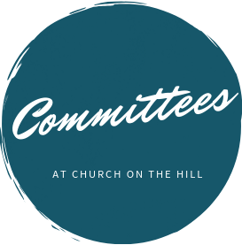

Buildings & Grounds
Chair: Joe Macaluso
Consistory Rep: Maureen
Saepia-Chen

Christian Education & Youth
Chair: Jeanne Sarran

Community, Mission & Outreach
Co-Chairs: Yoon Ryo &
Patrick Symes

Community Nursery
School Board
President: Ginny Chan
Consistory Rep: Dorien Day

Congregational Care
Co-Chairs: Angela Brunjes & Pamela Lopez
*Chairperson is also Consistory Representative unless otherwise stated.
_____________________________________________________________________________

Children are always welcome in worship at Church on the Hill. At the back of the sanctuary, the Family Room is open for young children and their parents. Restrooms are located downstairs in Gessner Hall, where you will find a changing table in one of the bathrooms.
_____________________________________________________________________________

_____________________________________________________________________________

The sanctuary is looped for the hard of hearing. In order to connect to the system, please sit in the north set of pews (on your right when you enter the sanctuary) and set your hearing device to the “T” setting.

Finance
Chair: Doris Krsnak
Consistory Rep: Margret
Dougherty

Personnel
Chair: Dana Chan

Worship & Music
Chair: Rev. Crawford
Consistory Rep: Irma Schubert

Rev. Blaine Crawford, President
Nancy Gessner, Clerk
Elders | Deacons
Angela Brunjes | Dana Chan
Dorien Day | Margaret Dougherty
Pam Lopez | Yoon Ryo
Jeanne Sarran (VP) | Maureen Saepia-Chen
Irma Schubert | Patrick Symes

Rev. Blaine Crawford, Minister: pastor@churchonthehill.org
Sean Cotty, Music Director: sean.cotty@churchonthehill.org
Molly Mahowald, Office Administrator: office@churchonthehill.org

*Revised Office Hours: M–F, 10:30 a.m.-3:30 p.m.
Phone: (718) 358-3671
www.churchonthehill.org

