Church on the Hill
A Congregation of the
Reformed Church in America
167-07 35th Avenue, Flushing, NY 11358
April 26, 2020
11:00 a.m.

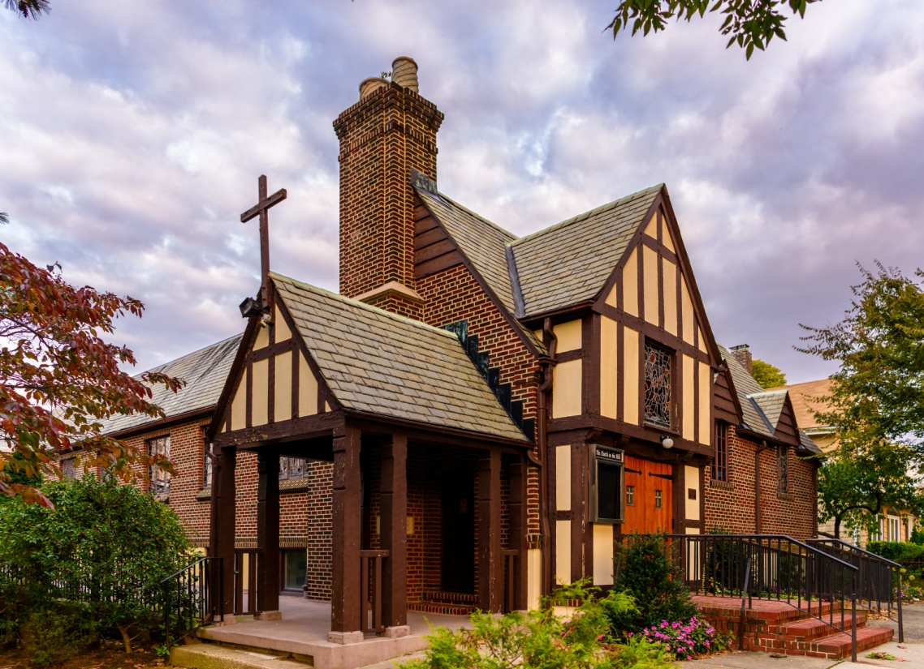
©Emerson Chen Photography

Rev. Blaine D. Crawford – Pastor
Mr. Sean Cotty – Music Director
Rev. Robert A. Perless – Pastor Emeritus

ORDER FOR WORSHIP
BOLD – Congregation responds

PRELUDE Improvisation on Patriotic Themes Sean Cotty

VOTUM

SENTENCES

PRAYER OF INVOCATION
Glorious Lord of life,
by the mighty resurrection of your Son
you overcame the old order of sin and death
to make all things new in him.
Grant that we who celebrate with joy
Christ’s rising from the dead
may be raised from the death of sin
to the life of righteousness,
through him who lives and reigns with you and the Holy Spirit,
one God, now and forever. Amen.

CALL TO WORSHIP

HYMN No. 495 My Faith Has Found A Resting Place
My faith has found a resting place,
not in device nor creed;
I trust the everliving One,
his wounds for me shall plead.

I need no other argument,
I need no other plea,
it is enough that Jesus died,
and that he died for me.

My great physician heals the sick,
the lost he came to save;
for me his precious blood he shed,
for me his life he gave.

I need no other argument,
I need no other plea,
it is enough that Jesus died,
and that he died for me.

PRAYER OF CONFESSION
O Lord, who loves us as a father, who cares for us as a mother,
who came to share our life as a brother,
we confess before you our failure to live as your children,
brothers and sisters bound together in love.
You accept us, but we do not accept others;
you forgive us, but we do not forgive those who wrong us;
you love us, but we do not love our neighbors.
Have mercy upon us.
(Silent prayers of confession and unburdening)
Amen.

ASSURANCE OF PARDON/WISDOM FOR LIFE
(Based on writings from 1 Peter)

SOLO The New 23rd Ralph Carmichael
Soloist: Dorien Day
Because the Lord is my shepherd,
I have everything that I need.
He lets me rest in meadows green
And leads me beside the quiet stream:
He keeps on giving life to me
And helps me to do what honors Him the most.

Even when walking through the dark valley of death,
I will never be afraid,
for he is close beside me,
Guarding, guiding all the way,
He spreads a feast before me
In the presence of my enemies
He welcomes me as His special guest
with blessing overflowing.

His goodness and unfailing kindness
shall be with me all of my life,
and afterwards I will live with Him,
Forever and ever, in His home.

PRAYER OF ILLUMINATION
Guide us, O God,
by your Word and Spirit,
that in your light we may see light,
in your truth find freedom,
and in your will discover your peace,
through Jesus Christ, our Lord. Amen.

SCRIPTURE READINGS
Acts 2:14a, 36-41
1 Peter 1:13-23
This is the Word of the Lord.
Thanks be to God.

SERMON Holiness: Given or Learned? Rev. Blaine
Crawford

CONFESSION OF FAITH
The mystery of the faith:
Christ has died. Christ is risen! Christ will come again!

HYMN No. 661 Be Strong In the Lord
Be strong in the Lord, and be of good courage;
your mighty defender is always the same.
Mount up with wings, as the eagle ascending;
victory is sure when you call on his name.

Be strong, be strong, be strong in the Lord,
and be of good courage for he is your guide.
Be strong, be strong, be strong in the Lord,
and rejoice for the victory is yours.

Be strong in the Lord, and be of good courage;
your mighty commander will vanquish the foe.
Fear not the battle for the victory is always his;
he will protect you wherever you go.

Be strong, be strong, be strong in the Lord,
and be of good courage for he is your guide.
Be strong, be strong, be strong in the Lord,
and rejoice for the victory is yours.

PRAYERS OF THE PEOPLE
Lord’s Prayer
Our Father, who art in heaven,
hallowed by Thy name.
Thy Kingdom come, thy will be done,
on earth as it is in Heaven.
Give us this day our daily bread;
and forgive us our trespasses
as we forgive those who trespass against us.
Lead us not into temptation,
but deliver us from evil.
For thine is the Kingdom and the power
And the glory, forever. Amen.

ANNOUNCEMENTS

BENEDICTION

POSTLUDE Etude in F Major Chopin

If you would like to add a loved one to the prayer list,
please contact the church office.

Miram Allen
John Babinsky
Diane Blagburn
The Bonsaing Family
Elizabeth Bossis
The Calamusso Family
Lillian Calfa
David Cerqueira
Gracinda Cerqueira
Jose Cerqueira
Christopher Cooney
Marilyn Cooney
Edward Cotty
The Cotty & McGowan Families
Helen Cunningham
Rosina Cuticone
Lenny DeSimone
Herb Durdik
The Frocione Family
Brooke Graffeo
Rosemarie Graffeo
Jayne Halley
Bill Haasters’ Family
Hotchkiss Family
Jane Lynch
Ed Mangiarotti
Jorge & Tiffany Martinez
Gerry & Jean Mendler
Ruben & Eva Munoz
Patricia Olney
The Ryo Family
The Smith Family
Joe Thorsen
Christie Tweed
Alison Venable
Joan Werbel
Sandy Weston

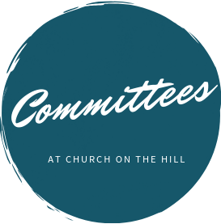

Buildings & Grounds
Chair: Joe Macaluso
Consistory Rep: Maureen
Saepia-Chen

Christian Education & Youth
Chair: Jeanne Sarran

Community, Mission & Outreach
Co-Chairs: Yoon Ryo &
Patrick Symes

Community Nursery
School Board
President: Ginny Chan
Consistory Rep: Dorien Day

Congregational Care
Co-Chairs: Angela Brunjes & Pamela Lopez
*Chairperson is also Consistory Representative unless otherwise stated.
_____________________________________________________________________________

Children are always welcome in worship at Church on the Hill. At the back of the sanctuary, the Family Room is open for young children and their parents. Restrooms are located downstairs in Gessner Hall, where you will find a changing table in one of the bathrooms.
_____________________________________________________________________________

_____________________________________________________________________________

The sanctuary is looped for the hard of hearing. In order to connect to the system, please sit in the north set of pews (on your right when you enter the sanctuary) and set your hearing device to the “T” setting.

Finance
Chair: Doris Krsnak
Consistory Rep: Margret
Dougherty

Personnel
Chair: Dana Chan

Worship & Music
Chair: Rev. Crawford
Consistory Rep: Irma Schubert

Rev. Blaine Crawford, President
Nancy Gessner, Clerk
Elders | Deacons
Angela Brunjes | Dana Chan
Dorien Day | Margaret Dougherty
Pam Lopez | Yoon Ryo
Jeanne Sarran (VP) | Maureen Saepia-Chen
Irma Schubert | Patrick Symes

Rev. Blaine Crawford, Minister: pastor@churchonthehill.org
Sean Cotty, Music Director: sean.cotty@churchonthehill.org
Molly Mahowald, Office Administrator: office@churchonthehill.org

*Revised Office Hours: M–F, 10:30 a.m.-3:30 p.m.
Phone: (718) 358-3671
www.churchonthehill.org

