Church on the Hill
A Congregation of the
Reformed Church in America
167-07 35th Avenue, Flushing, NY 11358
April 19, 2020
11:00 a.m.

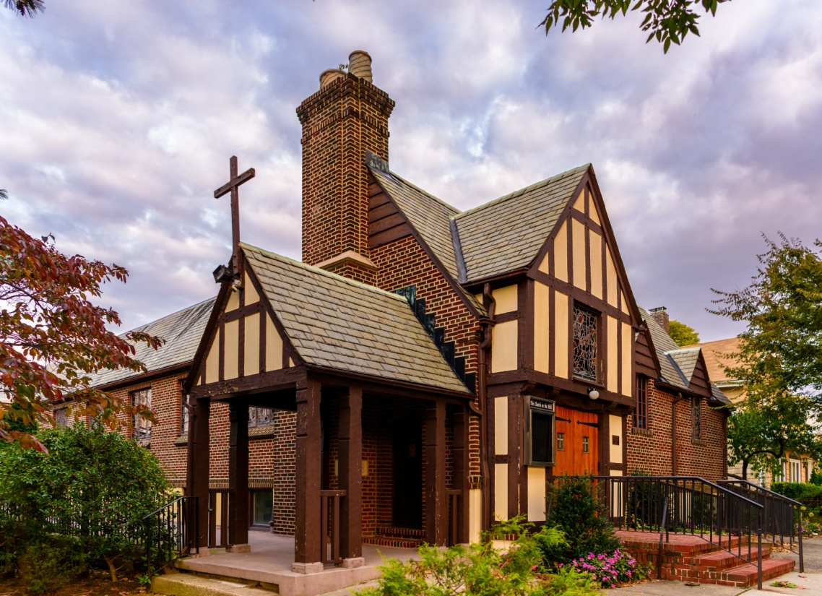
©Emerson Chen Photography

Rev. Blaine D. Crawford – Pastor
Mr. Sean Cotty – Music Director
Rev. Robert A. Perless – Pastor Emeritus

ORDER FOR WORSHIP
BOLD – Congregation responds

PRELUDE Well-tempered Clavier Selections J.S. Bach

VOTUM

SENTENCES

PRAYER OF INVOCATION
Mighty God,
in whom we know the power of redemption,
you stand among us in the shadows of our time.
As we move through every sorrow and trial of this life,
uphold us with knowledge of the final morning
when, in the glorious presence of your risen Son,
we will share in his resurrection,
redeemed and restored to the fullness of life
and forever freed to be your people. Amen.

CALL TO WORSHIP

HYMN No. 239 I Know That My Redeemer Lives
I know that my Redeemer lives!
What joy this blest assurance gives!
He lives, he lives, who once was dead;
he lives, my ever-living Head!

He lives triumphant from the grave;
He lives eternally to save;
He lives exalted, throned above;
He lives to rule His church in love.
PRAYER OF CONFESSION
O Father, most gracious,
filled with mercy and steadfast love,
incline your ear to our troubles.
Hear us when we pour out our sorrows before you.
Forgive us,
not on the ground of our own righteousness,
but on the ground of your great mercy,
in the gift of your Son, Jesus Christ.
(Silent prayers of confession and unburdening)
Amen.

ASSURANCE OF PARDON/WISDOM FOR LIFE
(Based on writings from 1 Peter)

SOLO Antiphon 5a from Ralph Vaughan
Five Mystical Songs Williams
Soloist: Joe Mahowald
Let all the world in every corner sing, my God and King.
The heavens are not too high, His praise may tither fly:
The earth is not too low, His praises there may grow.
The Church with Psalms must shout, no door can keep them out: But above all, the heart must bear the longest part.

PRAYER OF ILLUMINATION
Open our hearts to your power moving
around us and between us and within us,
until your glory is revealed in our love of both friend and enemy, in communities transformed by justice and compassion, and in the healing of all that is broken.
Amen.

SCRIPTURE READINGS
Acts 2:14a, 22-32
1 Peter 1:3-9
This is the Word of the Lord.
Thanks be to God.

SERMON Pop Quiz Rev. Blaine Crawford

CONFESSION OF FAITH
The mystery of the faith:
Christ has died. Christ is risen! Christ will come again!

HYMN No. 263 Alleluia, Sing to Jesus
Alleluia, sing to Jesus! his the scepter, his the throne:
Alleluia! His the triumph, his the victory alone.
Hark! The songs of peaceful Zion Thunder like a mighty flood. Jesus, out of every nation, has redeemed us by his blood.

Alleluia! Heavenly High Priest, here on earth our help, our stay: Alleluia! Hear the sinful cry to you from day to day.
Intercessor, friend of sinners, earth's Redeemer, hear our plea, where the songs of all the sinless sweep across the crystal sea.

PRAYERS OF THE PEOPLE
Lord’s Prayer
Our Father, who art in heaven,
hallowed by Thy name.
Thy Kingdom come, thy will be done,
on earth as it is in Heaven.
Give us this day our daily bread;
and forgive us our trespasses
as we forgive those who trespass against us.
Lead us not into temptation,
but deliver us from evil.
For thine is the Kingdom and the power
And the glory, forever. Amen.

ANNOUNCEMENTS

BENEDICTION

POSTLUDE Improvisation on Hyfrydol Sean Cotty

If you would like to add a loved one to the prayer list,
please contact the church office.

Miram Allen
John Babinsky
Diane Blagburn
The Bonsaing Family
Elizabeth Bossis
The Calamusso Family
Lillian Calfa
David Cerqueira
Gracinda Cerqueira
Jose Cerqueira
Christopher Cooney
Marilyn Cooney
Edward Cotty
The Cotty & McGowan
Families
Helen Cunningham
Rosina Cuticone
Lenny DeSimone
Herb Durdik
The Frocione Family
Brooke Graffeo
Rosemarie Graffeo
Jayne Halley
Hotchkiss Family
Jane Lynch
Ed Mangiarotti
Jorge & Tiffany Martinez
Jean Mendler
Ruben & Eva Munoz
The Ryo Family
Joe Thorsen
Christie Tweed
Alison Venable
Joan Werbel
Sandy Weston

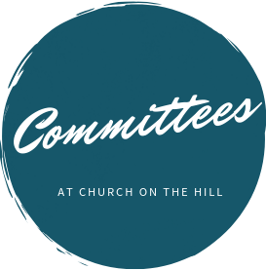

Buildings & Grounds
Chair: Joe Macaluso
Consistory Rep: Maureen
Saepia-Chen

Christian Education & Youth
Chair: Jeanne Sarran

Community, Mission & Outreach
Co-Chairs: Yoon Ryo &
Patrick Symes

Community Nursery
School Board
President: Ginny Chan
Consistory Rep: Dorien Day

Congregational Care
Co-Chairs: Angela Brunjes & Pamela Lopez
*Chairperson is also Consistory Representative unless otherwise stated.
_____________________________________________________________________________

Children are always welcome in worship at Church on the Hill. At the back of the sanctuary, the Family Room is open for young children and their parents. Restrooms are located downstairs in Gessner Hall, where you will find a changing table in one of the bathrooms.
_____________________________________________________________________________

_____________________________________________________________________________

The sanctuary is looped for the hard of hearing. In order to connect to the system, please sit in the north set of pews (on your right when you enter the sanctuary) and set your hearing device to the “T” setting.

Finance
Chair: Doris Krsnak
Consistory Rep: Margret
Dougherty

Personnel
Chair: Dana Chan

Worship & Music
Chair: Rev. Crawford
Consistory Rep: Irma Schubert

Rev. Blaine Crawford, President
Nancy Gessner, Clerk
Elders | Deacons
Angela Brunjes | Dana Chan
Dorien Day | Margaret Dougherty
Pam Lopez | Yoon Ryo
Jeanne Sarran (VP) | Maureen Saepia-Chen
Irma Schubert | Patrick Symes

Rev. Blaine Crawford, Minister: pastor@churchonthehill.org
Sean Cotty, Music Director: sean.cotty@churchonthehill.org
Molly Mahowald, Office Administrator: office@churchonthehill.org

*Revised Office Hours: M–F, 10:30 a.m.-3:30 p.m.
Phone: (718) 358-3671
www.churchonthehill.org

