Church on the Hill
A Congregation of the
Reformed Church in America
167-07 35th Avenue, Flushing, NY 11358
Easter Sunday
April 12, 2020
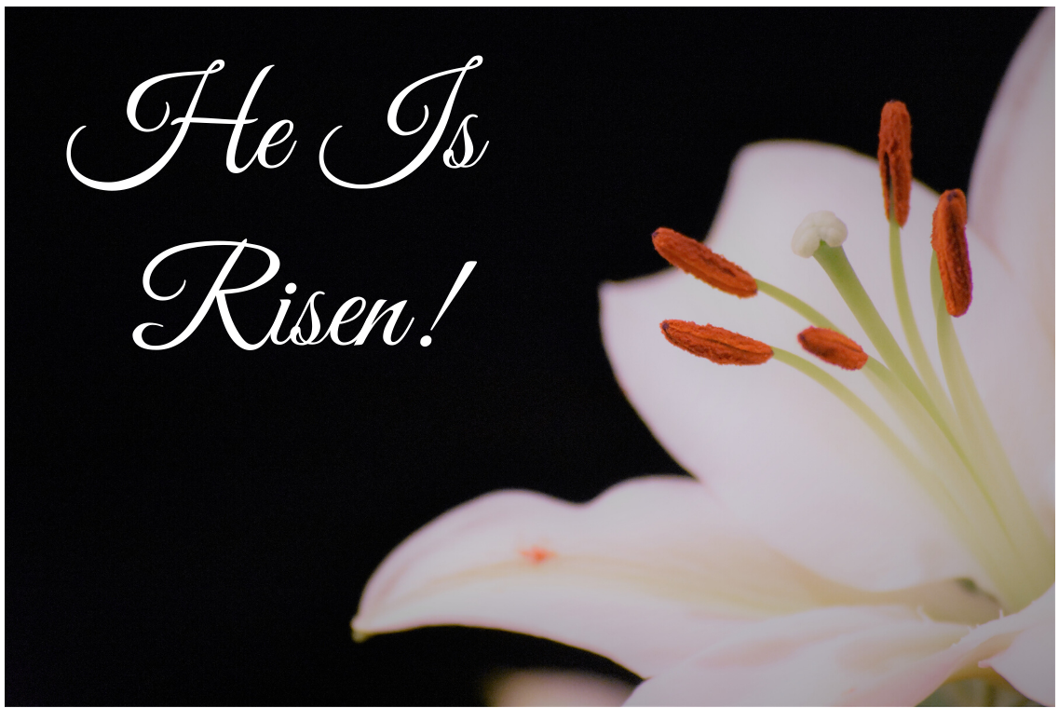

Rev. Blaine D. Crawford – Pastor
Mr. Sean Cotty – Music Director
Rev. Robert A. Perless – Pastor Emeritus

ORDER FOR WORSHIP
BOLD – Congregation responds

PRELUDE Improvisation on Ode to Joy Sean Cotty

SENTENCES
Alleluia! Christ is risen!
The Lord is risen indeed! Alleluia!
Jesus said, “I have come that they may have life
and may have it to the full.”
Alleluia! Christ is risen!
The light shines in the darkness,
And the darkness can never put it out.
Alleluia! Christ is risen!
For I am convinced that neither death nor life, nor angels, nor rulers, nor things present, nor things to come, nor powers, nor height, nor depth, nor anything else in all creation will be able to separate us form the love of God in Christ Jesus our Lord.
Alleluia! Christ is risen!
The Lord is risen indeed.

PRAYER OF INVOCATION

CALL TO WORSHIP
(Based on Psalm 16)
Protect me, O God, for in you I take refuge. I say to the LORD, “You are my Lord: I have no good apart from you.”
The LORD is my chosen portion and my cup; you hold my lot. The boundary lines have fallen for me in pleasant places; I have a goodly heritage.

I bless the LORD who gives me counsel; in the night also my heart instructs me. I keep the LORD always before me; because he is at my right hand, I shall not be moved.

Therefore my heart is glad, and my soul rejoices; my body also rests secure. For you do not give me up to Sheol, or let your faithful one see the Pit.

You show me the path of life. In your presence there is fullness of joy; in your right hand are pleasures forevermore.

HYMN No. 254 Alleluia, Alleluia! Hearts to Heaven
Alleluia, alleluia! Hearts to heaven and voices raise:
sing to God a hymn of gladness, sing to God a hymn of praise; He who on the cross a victim for the world's salvation bled, Jesus Christ, the King of Glory, now is risen from the dead.

Alleluia, alleluia! Glory be to God on high!
Alleluia to the Savior who has gained the victory!
Alleluia to the Spirit, fount of love and sanctity!
Alleluia, alleluia to the Triune Majesty!

PRAYER OF CONFESSION
Lord, bring new life where we are worn and tired;
new love where we have turned hard-hearted;
forgiveness where we feel hurt and where we have wounded; and the joy and freedom of your Holy Spirit where we are prisoners of ourselves.
(Silent prayers of confession and unburdening)
Amen.

ASSURANCE OF PARDON/WISDOM FOR LIFE
(Based on Ephesians 2:4-7)
God, who is rich in mercy,
out of the great love with which he loved us
even when we were dead through our trespasses,
made us alive together with Christ—by grace you have been saved—and raised us up with him and seated us with him in the heavenly places in Christ Jesus,
so that in the ages to come he might show
the immeasurable riches of his grace
in kindness toward us in Christ Jesus.

SOLO The Holy City Stephen Adams
Soloist: Emerson Chen
Last night I lay asleeping
There came a dream so fair
I stood in old Jerusalem
Beside the temple there
I heard the children singing
And ever as they sang
Methought the voice of Angels
From Heaven in answer rang
"Jerusalem, Jerusalem!
Lift up your gates and sing,
Hosanna in the highest.
Hosanna to your King!"
And then methought my dream was chang'd
The streets no longer rang
Hushed were the glad Hosannas
The little children sang
The sun grew dark with mystery
The morn was cold and chill
As the shadow of a cross arose
Upon a lonely hill
"Jerusalem, Jerusalem!
Hark! How the Angels sing,
Hosanna in the highest,
Hosanna to your King!"
And once again the scene was changed
New earth there seemed to be
I saw the Holy City
Beside the tideless sea
The light of God was on its streets
The gates were open wide
And all who would might enter
And no one was denied
No need of moon or stars by night
Or sun to shine by day
It was the new Jerusalem
That would not pass away
“Jerusalem! Jerusalem
Sing for the night is o'er
Hosanna in the highest
Hosanna for evermore!”

PRAYER OF ILLUMINATION
God of life,
your Spirit raised Jesus from dead.
Your Spirit inspired the prophets and writers of Scripture.
Your Spirit draws us to Christ
and helps us to acknowledge him as Lord.
We ask that you will send your Spirit now
to give us deeper insight, encouragement, faith, and hope
through the proclamation of the Easter gospel. Amen.

SCRIPTURE PASSAGES
Isaiah 25:6-9
John 20:1-23
This is the Word of the Lord.
Thanks be to God.

SERMON Waiting for Peace Rev. Blaine
Crawford

SOLO Alleluia from Exultate Jubilate W. A. Mozart
Soloist: Maureen Saepia-Chen

CONFESSION OF FAITH
Apostles’ Creed
I believe in God the Father Almighty, maker of Heaven and earth;
and in Jesus Christ his only Son our Lord: who was conceived by the Holy Spirit, born of the Virgin Mary, suffered under Pontius Pilate, was crucified, dead and buried; he descended into hell; the third day he rose from the dead; he ascended into heaven and sitteth at the right hand of God the Father Almighty; from thence he shall come to judge the quick and the dead.
I believe in the Holy Spirit, the holy Catholic Church, the communion of saints, the forgiveness of sins, the resurrection of the body, and the life everlasting. Amen.

HYMN No. 234 Christ the Lord Is Risen Today
Christ the Lord is risen today, Alleluia!
All creation, join to say Alleluia!
Raise your joys and triumphs high, Alleluia!
Sing, ye heavens, and earth reply, Alleluia!

Soar we now where Christ has led, Alleluia!
Following our exalted Head, Alleluia!
Made like him, like him we rise, Alleluia!
Ours the cross, the grave, the skies. Alleluia!

PRAYERS OF THE PEOPLE
Lord’s Prayer
Our Father, who art in heaven,
hallowed by Thy name.
Thy Kingdom come, thy will be done,
on earth as it is in Heaven.
Give us this day our daily bread;
and forgive us our trespasses
as we forgive those who trespass against us.
Lead us not into temptation,
but deliver us from evil.
For thine is the Kingdom and the power
And the glory, forever. Amen.

BENEDICTION

POSTLUDE Improvisation on Sean Cotty
Christ The Lord is Risen Today

Miram Allen
John Babinsky
Diane Blagburn
The Bonsaing Family
Elizabeth Bossis
The Calamusso Family
Lillian Calfa
Frank Cammarata &
Family
David Cerqueira
Gracinda Cerqueira
Jose Cerqueira
Marilyn Cooney
Edward Cotty
Helen Cunningham
Rosina Cuticone

Lenny DeSimone
Herb Durdik
The Frocione Family
Brooke Graffeo
Jayne Halley
Hotchkiss Family
Jane Lynch
Jorge & Tiffany
Martinez
Jean Mendler
Ruben & Eva Munoz
Joe Thorsen
Christie Tweed
Alison Venable
Joan Werbel
Sandy Weston

