Church on the Hill
A Congregation of the
Reformed Church in America
167-07 35th Avenue, Flushing, NY 11358
Good Friday
April 10, 2020
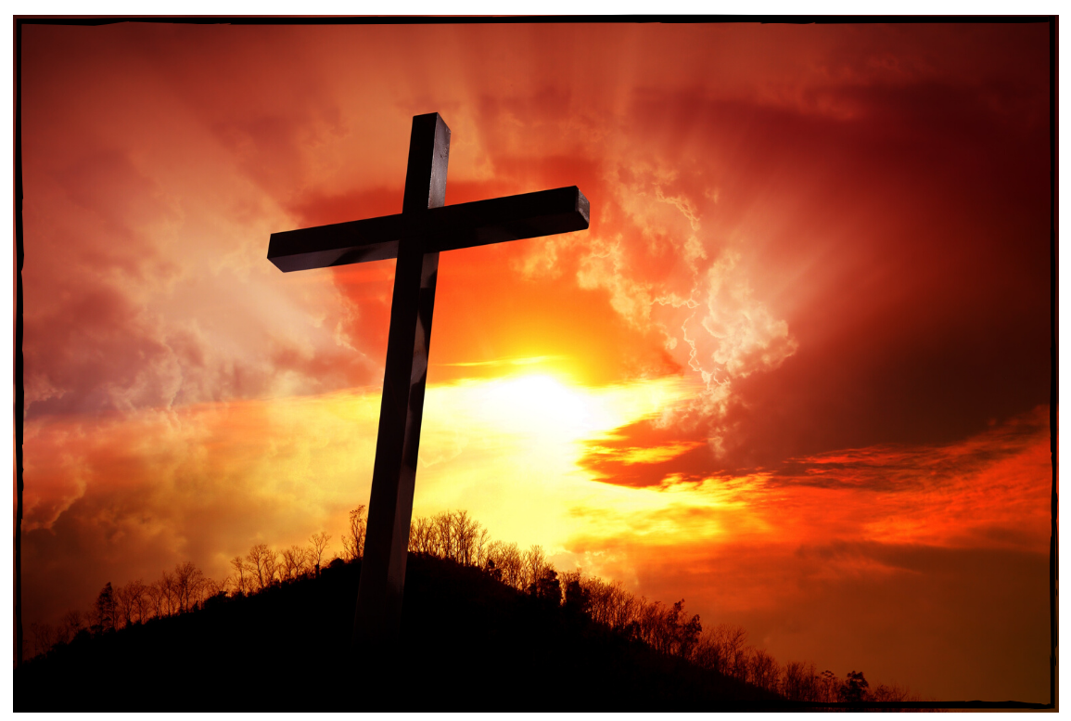

“It Is Finished.”

Rev. Blaine D. Crawford – Pastor
Mr. Sean Cotty – Music Director
Rev. Robert A. Perless – Pastor Emeritus

ORDER FOR WORSHIP
BOLD – Congregation responds

PRELUDE Concerto in c-minor (Movement II) J.C. Bach
Violist: Hector Milete

SOLO Were You There?
Soloist: Elizabeth Mahowald
Were you there when they crucified my Lord?
Oh! Sometimes it causes me to tremble, tremble, tremble.
Were you there when they crucified my Lord?

Were you there when they nailed him to the tree?
Oh! Sometimes it causes me to tremble, tremble, tremble.
Were you there when they nailed him to the tree?

Were you there when they laid him in the tomb?
Oh! Sometimes it causes me to tremble, tremble, tremble.
Were you there when they laid him in the tomb?

GREETING

PRAYER OF INVOCATION

CALL TO WORSHIP
(From Psalm 22)
But you, O Lord, do not be far away! O my help, come quickly to my aid! Deliver my soul from the sword, my life from the power of the dog! Save me from the mouth of the lion! From the horns of the wild oxen you have rescued me. I will tell of your name to my brothers and sisters; in the midst of the congregation I will praise you: You who fear the Lord, praise him! All you offspring of Jacob, glorify him; stand in awe of him, all you offspring of Israel! For he did not despise or abhor the affliction of the afflicted; he did not hide his face from me, but heard when I cried to him. From you comes my praise in the great congregation; my vows I will pay before those who fear him. The poor shall eat and be satisfied; those who seek him shall praise the Lord. May your hearts live forever! All the ends of the earth shall remember and turn to the Lord; and all the families of the nations shall worship before him. For dominion belongs to the Lord, and he rules over the nations. To him, indeed, shall all who sleep in the earth bow down; before him shall bow all who go down to the dust, and I shall live for him. Posterity will serve him; future generations will be told about the Lord, and proclaim his deliverance to a people yet unborn, saying that he has done it.

SOLO Via Dolorosa Billy Sprague &
Soloist: Joe Mahowald Niles Borop
Down the Via Dolorosa in Jerusalem that day,
the soldiers tried to clear the narrow streets,
but the crowd pressed in to see,
the man condemned to die on Calvary.

He was bleeding from a beating, there were striped upon His back,
and He wore a crown of thorns upon His head,
and He bore with every step
the scorn of those who cried out for His death.

Down the Via Dolorosa, called the way of suffering
like a lamb came the Messiah Christ the King.
But He chose to walk that road out of His love for you and me.
Down the Via Dolorosa all the way to Calvary.

The blood that would cleanse the souls of all the men,
made its way through the heart of Jerusalem.

SCRIPTURE READING
Isaiah 53:2-6

SOLO Elegy Gabriel Faure
Violist: Hector Milete

SCRIPTURE READING
John 19:14-37

SOLO O Sacred Head, Now Wounded Hans Leo
Soloist: Dorien Day Hassler
O sacred head, now wounded, with grief and shame weighed down, now scornfully surrounded with thorns, thine only crown: O sacred head, what glory, what bliss till now was thine; yet, though despised and glory, I joy to call thee mine.

What thou, my Lord, hast suffered was all for sinners' gain;
mine, mine was the transgression, but thine the deadly pain. Lo, here I fall, my Savior! 'Tis I deserve thy place;
look on me with thy favor, and grant to me thy grace.

What language shall I borrow to thank thee, dearest friend, for this thy dying sorrow, thy dying without end?
O make me thine forever; and should I fainting be,
Lord, let me never, never outlive my love to thee.

SCRIPTURE READING
Hebrews 10:16-23

HOMILY Rev. Blaine Crawford

DUET Ave Verum Karl Jenkins
Soloists: Elizabeth & Joe Mahowald
(Sung in Latin)
Hail, true Body, born
of the Virgin Mary,
having truly suffered, sacrificed
on the cross for mankind,
from whose pierced side

water and blood flowed:
Be for us a foretaste [of the Heavenly banquet]
in the trial of death!
.
O sweet Jesus, O holy Jesus,
O Jesus, son of Mary,
have mercy on me. Amen.

PRAYERS OF THE PEOPLE

BENEDICTION

POSTLUDE: Elegy Elliott Carter
Violist: Hector Milete

Miram Allen
John Babinsky
Diane Blagburn
The Bonsaing Family
Elizabeth Bossis
The Calamusso Family
Lillian Calfa
Frank Cammarata &
Family
David Cerqueira
Gracinda Cerqueira
Jose Cerqueira
Marilyn Cooney
Edward Cotty
Helen Cunningham
Rosina Cuticone

Lenny DeSimone
Herb Durdik
The Frocione Family
Brooke Graffeo
Jayne Halley
Hotchkiss Family
Jane Lynch
Jorge & Tiffany
Martinez
Jean Mendler
Ruben & Eva Munoz
Joe Thorsen
Christie Tweed
Alison Venable
Joan Werbel
Sandy Weston

